1. Modified class diagram using observer pattern

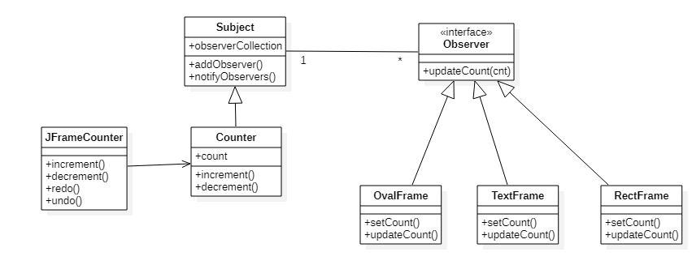

1. Sequence diagram that shows when,
2. The user clicks the increment button

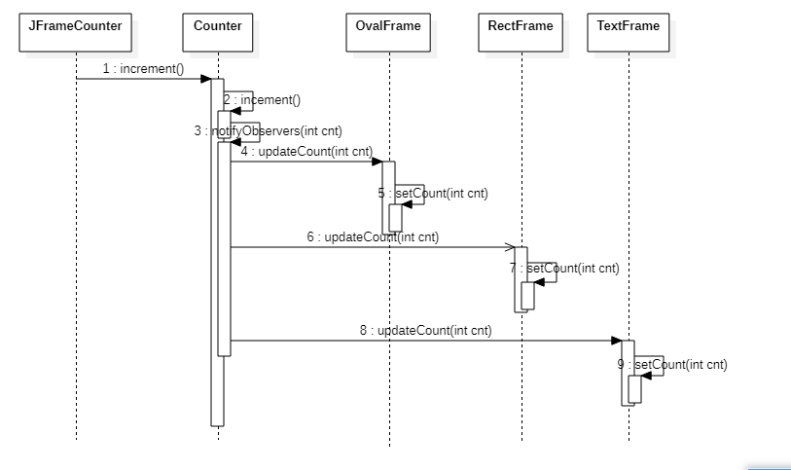

1. The user clicks the decrement button

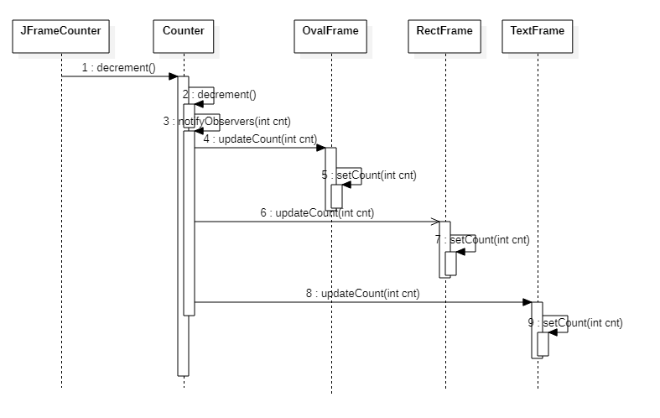

1. Modified code attached.
2. Account Question
3. Modified class diagram using the Observer pattern

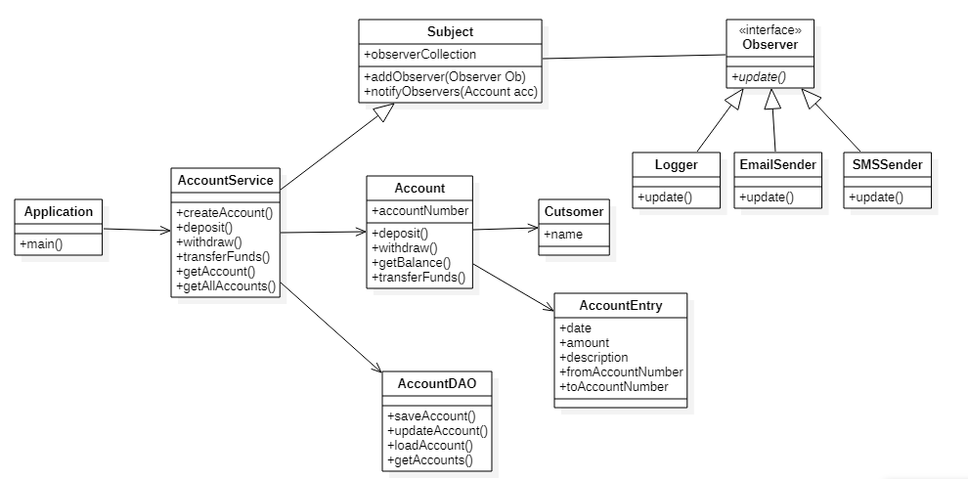

1. Sequence diagram for creation and depositing into a new account.

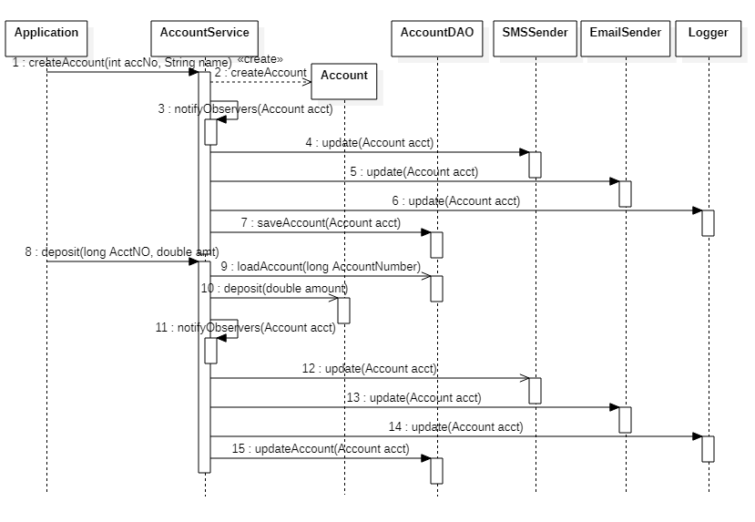

1. Modified code attached.